

#### *DEPARTMENT OF COMPUTER SCIENCE ENGINEERING, SCHOOL OF ENGINEERING AND TECHNOLOGY, SHARDA UNIVERSITY, GREATER NOIDA*

**PLANT LEAF DISEASE DETECTION USING DEEP LEARNING**

#### *A project submitted*

#### *In partial fulfillment of the requirements for the degree of Bachelor of Technology in Computer Science and Engineering*

#### *By:*

**SUHAIL SAIFI(2018013282)**

**BAL MUKUND(2018014062)**

**DANISH ALAM(2018007647)**

**Supervised by:**

**Dr. Ruqaiya Khanam,Prof(CSE)**

**May,2022**

**CERTIFICATE**

This is to certify that the report entitled “**Plant Leaf Disease Detection Using Deep Learning**” submitted by “Mr. SUHAIL SAIFI (2018013282), DANISH ALAM (2018007647), BAL MUKUND (2018014062)” to Sharda University, towards the fulfillment of requirements of the degree of “**Bachelor of Technology**” is record of bonafide final year Project work carried out by him in the “Department of Computer Science and Engineering, School of Engineering and Technology, Sharda University”.

##### The results/findings contained in this Project have not been submitted in part or full to any other University/Institute for award of any other Degree/Diploma.

##### Signature of Supervisor

##### Name: Dr. Ruqaiya Khanam

##### Designation: Prof (CSE)

##### Signature of Head of Department

##### Name: Prof. (Dr.) Nitin Rakesh

##### Place:

##### Date:

**Signature of External Examiner**

**Date:**

**Acknowledgement**

A major project is a golden opportunity for learning and self-development. We consider ourself very lucky and honored to have so many wonderful people to lead us through in completion of this project.

First and foremost we would like to thank Dr. Nitin Rakesh, HOD, CSE who gave us an opportunity to undertake this project.

Our grateful thanks to **Dr. Ruqaiya Khanam** for her guidance in my project work.

**Dr. Ruqaiya Khanam,** who in spite of being extraordinarily busy with academics, took time out to hear, guide and keep us on the correct path. We do not know where we would have been without his help.

The CSE department monitored our progress and arranged all facilities to make life easier. We choose this moment to acknowledge their contribution gratefully.

Name and signature of Students

SUHAIL SAIFI (2018013282)

DANISH ALAM (2018007647)

BAL MUKUND (2018014062)

**ABSTRACT**

Identification of plant disease plays an important role as it prevents stunted growth which causes bad effects on yields. As agriculture plays a vital role in the Indian economy and different countries of the world, so there is a need to prevent losses in terms of production, quality, and quantity of agriculture yields due to plant disease. Earlier farmers used to monitor plant disease with the naked eye which was time-consuming and required a lot of expertise such as being able to identify a disease and disease-causing agent. But nowadays with advancements in technology, smart farming, and automatic techniques, plant disease can be easily identified and proper diagnosis can be done. It reduces a lot of work of monitoring such as in the case of big farms. Also at an early stage, it detects the symptoms of plant disease when they first appear on leaves. This paper reflects the potential of one such method-Plant disease detection using machine learning, using which one can detect plant disease. It includes the use of image processing techniques with the help of a machine learning algorithm to get a clear and defined image or to extract some useful insight from it. Also, CNN is used for image classification. CNNs are equipped with input, output, and hidden layers which help in process and in image classification.

***Index Terms–***Disease Detection, K-means clustering, image processing, unhealthy leaf detection

**Contents**

Title Page……………………………………………………………………………………. 1

CERTIFICATE………………………………………………………………………………. 2

ACKNOWLEDGEMENT…………………………………………………………………… 3

Abstract……………………………………………………………………………………… 4

Chapter1: INTRODUCTION……………………………………………..………………… 7

* 1. Problem Definition…………………………………………………………………… 7
  2. Project Overview/ Requirement Specifications…………………………………... 8
  3. Hardware Specifications……………………………………………………………. 9
  4. Software Specifications……………………………………………………………... 11

Chapter2: Literature Survey……………………………………………………………….. 13

* 1. Existing System:................................................................................................ 13
  2. Proposed System……………………………………………..…………………….. 21
  3. Feasibility Study……………………………………..……………………………… 23
  4. Risk Management :........................................................................................... 24

Chapter 3: System Analysis and Design…………………….…………………….…….. 26

1. Software Requirement Specification ……………………………………………….. 26

2. Flowchart………..……………………………………………………………………... 28

3. Design and Test ………………………………………………………………………. 29

4. Testing Process ……………………………………………………………................ 34

Chapter 4: RESULTS / OUTPUTS…………………………………..…………………… 42

Chapter 6: Conclusion………………………………………………………………….. … 50

Chapter 7: References…………………………………………………………………….. 51

**Chapter1: INTRODUCTION**

**1.1: Problem Definition**

This 'Plant Leaf Disease Detection Using Deep Learning' project is a software algorithm that can effectively detect leaf disease on an image input. This project reflects the potential of image processing techniques with the help of a deep learning algorithm to get a clear and defined image or to extract some useful insight from it. Also, CNN is used for image classification. CNNs are equipped with input, output, and hidden layers which help in process and in image classification. The primary goal of this project is to create the "Leaf Disease Detection" expert system, which employs a Deep Learning approach to define any type of leaf disease.

Deep Learning (DL) is one of the various subclasses of Machine Learning, and it has so far gone into three different stages of developments. The first generation originated in 1943 and its name was MCP, and was only useful in linear classification problems. Back Propagation (BP) was the second generation of the neural network. It was invented by Hinton in 1986. Nonlinear classification and mapping were also solved with the help of sigmoid functions, but around 1991 some problems of gradient vanishing were pointed out. Deep Learning (DL) is the third generation of neural networks. It was introduced in 2006, and as of now many DL models or architectures are being used for image detections or recognition.

As we wanted to formulate a real-time Plant Disease Detection System, to infer between the efficacy of pre-trained models over Multi-Class Dataset we collated Plant Leaf Dataset from Kaggle which is open to use. The Dataset consists of 15 Classes with a diverse variety of Plant Leaves. TensorFlow and Keras have been induced for working upon Deep Learning Architectures. OpenCv is used for reading and processing images. Numpy for saving the images in array format. Sklearn for one hot encoding,training and testing split, calculating the performance of the model. Matplotlib and Seaborn for plotting graphs in a much more advanced way. Gradio, an open-source python library for creating web-apps has also been utilized for creating a web app for Plant Disease Detection.

As the Data has been split into Train, and Test set. The Training Accuracy, and Test Accuracy has been used for explaining the architecture's potency over the particular dataset. Also, the Confusion Matrix is used for scrutinizing the model’s efficacy in real-time over different labels/classes.

**1.2: Project Overview/ Requirement Specification**

**1.2.1: Motivation:**

* To find the interactions between the diseases causing agents and the host plant in relation to the overall environment.
* To identify various diseases in plants.
* To implement a method for preventing the disease and providing management for reducing the losses/damages caused by diseases.
* Prevent diseases on plants for Farmers.
* Help out the pesticide company in predicting the new pesticide solutions.

**1.2.2: Overview:**

Plant disease detection has become a very big domain to work on, because many of the works have been done earlier using many different technologies and methods in this field. We so far have read some of the papers for our survey and have analyzed and have found many different results for different techniques and methods used. The papers were on the same topic but of different methodologies like few of them were based on MobileNetV2, DenseNet121 InceptionResNetV2 and VGG16 etc. We have analyzed that even after doing so much research in this domain, there is a large scope of research in the future also because every proposed model has some constraints, some disadvantages and some advantages. The need for a perfect model to detect the plant leaf disease is also in hunt and this is the reason that these models are not getting used on a large scale for disease detection. This is a very good and very helpful domain to work on because when farming is done on a very big scale, it is not possible for farmers to look for diseases on every leaf of the plants, so further research and findings on this domain can be very helpful.

**1.3: HARDWARE REQUIREMENTS**

| **Minimum Requirements** | **Windows** |
| --- | --- |
| **Operating System** | Windows 7 |
| **Processor** | Dual core, Intel i3 |
| **RAM** | 2 GB RAM |
| **DISK Space** | The amount of disc space available depends on the partition size and whether or not online help files are allowed. The MathWorks installer would tell you how  much disc volume your partition needs. |
| **Graphics Adapter** | 8-bit graphics adapter and display (for 256  simultaneous colors) |
| **CD_ROM drive** | For installation from CD |

| **Recommended Requirements** | | **Windows** |  |  |
| --- | --- | --- | --- | --- |
|  | **Processor** | **RAM** | **DISK Space** | **Graphics Adapter** |
| **PYCHARM-**  **Python IDE** | Intel i3 | 2 GB | 1 GB for Pycharm only.  5 GB for a typical installation | A 32-bit or 64-bit OpenGL capable graphics adapter is strongly  recommended |

**1.4: SOFTWARE REQUIREMENTS**

| Βrowser Used🡪 | Google Chrome |
| --- | --- |
| Language Used🡪 | Python |
| Τechnology & libraries Used🡪 | Tensorflow  Numpy  CNN  Keras  Matplotlib  Seaborn |
| Gradio, an open-source python library for creating web-apps | |

## 

* **Tensorflow** :- Tensorflow is an open source planning data data flow for all areas of operations. A number-related library is used for AI applications such as neural networks.
* **Google colab:-** Google collaboration (open-supply Jupyter Notebook interface with excessive GPU space). Google collaboration is an unencrypted Jupyter package that does not need to be set up and works perfectly in the cloud. With colab, you can really write and use code , save and analyze percentages. Access functional computing software, all at no cost in the browser. Jupyter Notebook is an effective way to duplicate and write in your Python code to analyze facts. Instead of rewriting and rewriting the entire code again and again. You can actually write code types and apply them at a time.
* **Seaborn:-** Seaborn is a python library for comprehension by viewing matplotlib. It provides an undeniable level of interaction in drawing attractive and useful measurable drawings. For a brief introduction to the ideas behind the library, you can look up the first notes or paper.
* **OS:-** The OS module in python enables enabling and completing enrollment(envelope), importing, modifying, and separating the current catalog, and more.
* **Matplotlib:-** Matplotlib is a python programming language library and extension of NumPy . Provides article-based API for installing episodes in applications using the most useful GUI toolboxes such as Tkinter,wxPython, Qt or GTK.
* **Pandas:-** Pandas explain() is used to view certain basic mathematical details such as percentage, total, std etc. of a data framework or a series of numerical values. When this method is used in a series of character units, it returns a different output.
* **NumPy:-** NumPy is a Python library used for running with collections. It additionally has the cappotenial to paintings withinside the area of direct polynomial calculations, 4 variables and frames. NumPy evolved in 2005 with the aid of Travis Oliphant. It is an open supply enterprise and you could use it sparingly. NumPy stands for Numerical Python.
* **Kaggle** was used to find an online dataset.
* **GitHub** and **stackoverflow** were used for reference in case of syntax editing errors.
* **Gradio:**- It is used for developing the Web App.
* **OpenCV:**- It is used to read and process images.
* **Sklearn:-** It is used for One hot encoding , train test split and calculating the performance of the model.
* **Language:-**
* **Python 3 -**  we have used python ,which is R-mathematical programming language instead of MATLAB for following reasons:

– Python records format improved in MATLAB

– Python code is much more understandable than MATLAB

– Keras (with backend of tensorflow) - keras is a neural community API that includes Tensorflow,CNTk, Theno etc. Python programs such as NumPy, Matplotlib, Pandas math and editing graphs.

* **HTML**
* **JavaScript**

**Chapter2: Literature Survey**

**2.1: Existing System:**

**Paper [1]** shows a Google Net model developed for 79 diseases of 14 different plant species in the experimental area and a complex field environment as a diagnostic tool. The advantage of this method is that the appearance of multiple pathogens in one leaf can be detected in many smaller images. The accuracy of this model was almost 94%.

**Paper [2]**, Dechant et al. showed a new CNN structure to identify the apple leaf disease. Using an Inception network and Alex Net-precursor network, the network was formed. Alex Net model got replaced by Inception network which reduced the number оf trаinаble раrаmeters, thereby reduсing stоrаge requirements. A single CNN gave the experimented result which shows the ассurасy rаte оf 90.8%. When we used twо first-level сlаssifiers, the ассurасy rаte beсаme 95.9%, and the accuracy rate rose to 97.8%, when three first –level qualifiers were used. The performance of this network was compared with SVM, BP, Alex Net, Google Net, ResNet20, and VGG16. The accuracy of these models was 68.73%, 54.63%, 91.19%, 95.69%, 92.76% and 96.32%, compared to 97.62%, which is the accuracy of the proposed Alex Net-precursor + Cascade Inception network.

**Paper [3]**, a well-known sub-field known as Few-Shot Learning (FSL) was introduced. FSL can solve neural network recognition problem and new classes that have not emerged from training; neural network recognition problem is difficult to integrate due to the small number of test samples, thus improving the accuracy of detection of small data sets. In databases where there are only a few images or many, the transfer learning method (TL) also has a problem with low visibility accuracy [23]. This is because it is a very difficult situation to learn different aspects of a deep network, and it leads to problems that are very difficult to integrate or over-install. Therefore, plant disease data sets containing single or small samples cannot support Deep Learning (DL) architecture training. On the other hand, the DL model (in-depth learning model) needs re-training in order to successfully recognize several new classes that do not appear in the training set. After extensive testing, the results showed that Fiw Shots Learning (FSL) could successfully achieve average 90% accuracy with the help of only 60 training images, which were much better than refined transmission learning, their accuracy was 73%.

**Paper [4]**, Emergence of accurate techniques inside the field of leaf-primarily based image type has proven surprising consequences. This paper makes use of Random woodland to come across diseased leaf from the facts sets created. Random forests are as a whole, learning approach for classification, regression and other obligations that operate through constructing woodland of the choice bushes all through the schooling time not like choice trees, Random forests conquer the drawback of over fitting in their schooling facts set and it handles each numeric and categorical facts. For extracting features of a photo, they used Histogram of an orientated Gradient (HOG). typical, they used device learning to train the big records units available to locate the ailment present in plant life. The histogram of oriented gradients (HOG) is an detail descriptor utilized as a part of computer vision and image processing for the sake of object detection. right here we are making usage of 3 thing descriptors: 1. Hu moments 2. Haralick texture3. colour Histogram. This paper also well-known shows the

accuracy of numerous gadgets gaining knowledge of models.

| **Various Machine learning models** | **Accuracy(percentage)** |
| --- | --- |
| Logistic regression | 65.33 |
| Support vector machine | 40.33 |
| K-nearest neighbour | 66.76 |
| CART | 64.66 |
| Random Forests | 70.14 |

**Paper [5]**, implementation of machine learning algorithm is seen to identify and detect a wide variety of plant diseases. Timely performance and high accuracy of Machine learning can be found with various backgrounds and disease coverage. Also has the ability to train itself and helps farmers to manage diseases effectively. Being platform agnostic TensorFlow Framework is used for the CNN model implementation. Tensor Flow is also known as data flow graphs because of its numerical operation. Graph nodes are represented by mathematical operation(s) and Multi-dimensional arrays are represented by the graph edges. In Tensorflow machine learning algorithms can be implemented easily and quickly. More than 80,000 images were used for training and validation with different backgrounds and images. It gives accurate information to farmers about the diseased plants. For training the model 60% images were used and the rest 40% for validation. Before detecting the disease, the interface used in KrishiMitr allows the user to select the plant type. To check its functioning, KrishiMitr was tested on a linux-based computer having a touch screen interface with a sensor for image acquisition. All codes of KrishiMitr are freely available on the internet.

**Paper [6],** this paper outlines a method for diagnosing plant disease based on color, edge detection and histogram pairing. Matching histogram is based on color scheme and edge detection methods. The methodology used in this study is divided into two main categories. The first phase deals with healthy sample training and disease sampling. The second phase deals with experimental sample training and produces results based on edge detection and histogram matching.

Each leaf has its own characteristics on the edges. Some leaf borders are saw, some are smooth and some have waves and so on. Also, the midrib alignment and vein pattern of the leaves are different. Therefore, the canny edge detection algorithm is used.

**Pарer [7],** et аl. K. Muthukаnnаn Fоund sроt disease in leaves and other diseаsed leаf tyрes using Neurаl Netwоrk Аlgоrithms. Different methods were used tо сlаssify the diseаsed рlаnt leаves suсh аs Feed Fоrwаrd Neurаl Netwоrk (FFNN), Leаrning Veсtоr Quаntizаtiоn (LVQ) аnd Rаdiаl Bаsis Funсtiоn Netwоrks (RBF).. Simulаtiоn results hаve shоwn the effeсtive result оf the sсheme. With the helр оf this wоrk, а mасhine leаrning bаsed system саn be fоrmed for the gооd сrор quality that helрs tо bооst the Indiаn Eсоnоmy.[1] Et. аl Mаlvikа Rаnjаn in the рарer Deteсted аnd Сlаssified Leаf Diseаse using Аrtifiсiаl Neurаl Netwоrk thаt сарtures the imаges. Segmentation and Artificial neural network (ANN) results gave the color feature like HSV which are used to train and distinguish the unhealthy samples appropriately. ANN gave an accuracy of 80% and showed effective experimental results. With the help of this method cotton leaf disease can be detected accurately. Et al. Syafiqah Ishakais have shown how to get useful insight and analytical data from leaf images which is used to classify healthy and diseased leaves of medicine plants using image processing methods. To extract images and to get data, an algorithm of adjusted contrast and segmentation is used. Experiment is performed using the Artificial Neural Network. Final experimental results show that the RBF network performance is better than the MLP network. By using deep convolutional networks, Srdjan Sladojevic developed a new approach towards plant disease detection using leaf image classification. This method facilitated a simple and efficient practice to detect disease in leaves. Model could recognize thirteen different types of plant diseases out of samples. To implement this disease detection model necessary steps are mentioned in this paper which can be useful to experts in agriculture. Caffe, developed by Berkeley Vision and Learning Center, was involved in deep CNN training. This model gave accuracy between 91% and 98% for experimented results. Et al. Emanuel Cortes used 86,147 images of diseased plants dataset and performed deep convolutional network and semi supervised methods to train and to classify crop species of 57 different classes. Also gave better results on the unsupervised data. It gave accuracy above 80% in the training phrase under 5 epochs with the learning rate of 1e-5.

**Paper [8],** the basic knowledge of in-intensity mastering additionally affords a comprehensive evaluation of the modern studies work performed at the analysis of plant leaf disease using in-depth studies. Whilst sufficient training statistics are available, in-depth studies methods are able to hit upon plant leaf diseases with higher accuracy. The significance of gathering big sets of information with excessive variability, data magnification, transfer readings, and mapping that enable CNN to enhance segment accuracy, in addition to the importance of small sample leaf disease and the significance of hyper-spectral pictures for early detection of the plant disease mentioned on the equal time, there are boundaries. Most of the proposed DL frames inside the books have accurate results to locate on their internet site, but the consequences aren't appropriate for different data units, which imply that the model has a vulnerable consistency. Consequently, better dynamic models of DL are needed to prepare information sets for numerous diseases. In a few studies, a Plant Village facts set was used to assess the performance of DL models. Even though this database contains many pictures of some plant species with their own diseases, it's been taken to the lab. Therefore, it is predicted that a first-rate database of plant illnesses will be installed in the real world.

Even though some research use hyper spectral photos of diseased leaves and a few DL prices are used to diagnose plant leaf disease early, troubles affecting the giant use of HSI in early detection of plant diseases continue to be to be solved. that is, at the primary detection of plant diseases, it's miles difficult to obtain written data sets, or even experienced professionals can mark while the disease signs are not detected, and define pixels for undiagnosed disease, most importantly for HSI to detect plant disorder.

**Paper [9],** there are many advanced methods for diagnosing and classifying plant sicknesses using diseased plant leaves. but, there may be no effective and effective business remedy that can be used to diagnose diseases. In our work, we've got used four different DL models (InceptionV3, InceptionResnetV2, EfficientNetB0, MobileNetV2) to detect plant diseases using healthy images and plant leaves. To train and test the model, we used the standard Plant Village database with 53,407 images, all taken under laboratory conditions. This database contains 38 different classes of 14 healthy and diverse leaf pictures. After dividing the database into 80–20 (80% of total training data, 20% of complete images for testing), we found a very high accuracy rate of 99.56% in the EfficientNetB0 model. On average, less time was needed to train images in MobileNetV2 and EfficientNetB0 formats, and it took 565 and 545 s / epoch, respectively, for colour photographs. Compared to other in-depth learning methods, the in-depth learning model used has a better ability to predict both accuracy and loss. The time required for model training was significantly lower than other machine learning methods. In addition, the MobileNetV2 architecture is a deep convolutional neural network that limits the number of parameters and functionality as possible, and can be easily implemented on mobile devices.

**Paper [10],** the main goal of this paper is to detect the sickness and take precautionary measures to protect the crop before it’s too late. By doing this prevents the loss to the farmers and helps to maintain the monetary growth. Also minimizes the use of pesticides. This paper shows the use of Histogram which is used to predict the features and give to the classification model. The histogram is used to represent the frequency distribution or used to summarize the continuous data on an interval scale. They came in handy to represent numerical data in a friendly manner. They identify the diseased leaf and send the messages to the farmers. In this paper, Tomato and maize leaves are taken and their disease is identified and predicted accurately using SVM and ANN algorithms. SVM is a supervised learning algorithm used for regression problems. It is primarily used for classification problems and also helpful in detecting outliers. It is highly effective in dimensional spaces. SVM shows better results in terms of generalization capabilities. ANN is software made by the inspiration of biological neurons which can emulate relationships and dependencies in a dataset. It is highly effective in terms of predicting the outcome of a new dataset. In this paper, they have shown different methodologies which include stages such as Data collection, Preprocessing, Feature extraction, Image segmentation, classification phases. They have used the dataset which contains 200 maize and tomato leaf features. Out of which 50 are healthy leaf and 110 leaf pictures are for training and testing. Here the use of SVM and ANN gave the accurate result. SVM gave 60 to 70 percentages. ANN gave 80 to 85 percentages. This methodology has been tested correctly on python software.

**Paper [11],** this paper provides a survey on various techniques and different classifiers aspects which can be used to detect the rice disease plant. They have also proposed a CNN model and a hardware prototype, using these different rice diseases such as rice blast, rice blight, brown spots, leaf smut, and sheath blight.

Also highlights different techniques and their comparison based on classifiers such as SVM, KNN, ANN, etc. SVM is a supervised learning algorithm used for regression problems. It is primarily used for classification problems and also helpful in detecting outliers. It is highly effective in dimensional spaces. SVM shows better results in terms of generalization capabilities. ANN is software made by the inspiration of biological neurons which can emulate relationships and dependencies in a dataset. KNN algorithm is mainly used for pattern classification tasks. It is a supervised learning algorithm that is an initial step in a machine learning setup. IT is used for both classifications as well as regression problems. It is highly effective in terms of predicting the outcome of a new dataset. The proposed method to detect the rice disease includes various stages such as Data acquisition which deals with the sample picture dataset and hardware module consisting of raspberry pi and multimedia sensors. Preprocessing and feature extraction is carried out. Then CNN classifier is used to identify the infected leaf. CNN is a deep neural network class that helps in image visualization. CNN is primarily used for image classification as it follows a hierarchal model to give higher accuracy.CNN is used in deep learning to recognize objects in an image. This proposed work also uses libraries such as panda, NumPy, TensorFlow. Also shown that CNN proposed model gave accuracy about 96 percentages. Also, able to identify diseases such as rice blast, blight, brown spots, etc. correctly and successfully. This model shows promising results and helps farmers to maintain their monetary growth.

**Paper [12]**, this paper shows a method to detect monocot and dicot plant disease. This paper mainly shows two categories of family plants such as Monocot and Dicot family types. Monocot plant is those which contains only one seed leaf and have straight and parallel vein structure. Examples: Wheat, corn, rice, etc. Dicot families are those plants that have two leaves. Dicot plants example is roses, geraniums, magnolias, etc. this paper shows how this method helps to detect disease with more accuracy. It includes three steps such as segmentation of leaf to segment the diseased leaf using the K-means algorithm. Segmentation is one of the techniques in machine learning in which an image is broken down into various image segments. This reduces the image complexity and thus helps in further image analysis. K-means algorithm is an unsupervised algorithm that helps to identify k number of centroids and facilitates to the allocation of data points to the nearest cluster. It is highly beneficial in business assumptions. It deals with vector quantization. Next comes feature extraction and the last step is a classification which is done using SVM. SVM is a supervised learning algorithm used for regression problems. It is primarily used for classification problems and also helpful in detecting outliers. It is highly effective in dimensional spaces. SVM shows better results in terms of generalization capabilities and also shows different techniques and their limitations. They have segmented the affected part and extracted the feature of the diseased leaf part. This paper helps farmers to maintain their monetary growth and detect the disease accurately.

**Paper [13]**, this examine has utilized deep mastering competencies to reap computerized plant ailment detection structures. This system is based on a easy type mechanism which exploits the function extraction functionalities of CNN. For prediction ultimately, the model makes use of the completely connected layers. The researches become done using the publicly on hand series of 70295 images, and a hundred photos from experimental conditions and real environment. The machine has achieved a standard 98% testing accuracy on publicly on hand dataset, and carried out well on snap shots of Sukkur IBA university vegetation. it is concluded from accuracy that CNN is fairly appropriate for automated detection and prognosis of flowers.

This machine may be integrated into mini-drones to stumble on diseases from flora in cultivated regions. Although this device is skilled on a Plant Village dataset with handiest 38 classes it can tell if the plant has a sickness or not as by some means symptoms are the same in all kinds of flowers. in addition, extra actual surroundings photographs may be introduced to the dataset to improve the accuracy on real-circumstance photographs of leaves and classify extra plant kinds in addition to disease kinds. inside the destiny, this system also can undertake a 3-layer method wherein the first layer detects if there’s any plant in an image or not, 2d layer tells the plant kind and the 0.33 layer tells if there is any disorder or no longer and what kind of disease is there if any.

**Paper [14],** in this paper, they mentioned how ML in standard and DL in particular helped to diagnose diseases in plant life whilst illnesses are not identified nicely, they disrupt the harvest and eventually lead to long-term troubles, such as global warming or even famine. The proposed work summarizes many studies on the evolution of plant diseases and the identification of different ML strains. The proposed manuscript also reflects a well-received list of CV methods on this site, making it a comprehensive area of ​​research that should be explored soon. [a] identification of disease is one of the main areas to pay attention. As each disease has many stage associated with it. Also systems must have the capabilities to suggest measures about specific disease stages. It helps to reduce damage percentage and boost the agricultural production. [b] Disease Quantification is another area. The extent of the damage caused by the disease must be identified. This plays an important role as remedial actions could be taken according to the disease severity. Helps to detect the infected proportion of a agricultural production. Also it helps to analyse whether specific chemicals are needed or not. As we know chemicals are harmful for the health. [c] Many Applications and articles are available about disease identification which is free to use. It does not give a fast and accurate result. So availability of this recognition model will help farmers to detect and identify disease which will help to increase to their revenue. [d] Dealing with the difficulty of the data, specifically during the training stage, the best option to look at is transfer learning- a heterogeneous domain. 3D convolution, temporal pooling, LSTMs, optical flow frames are some of the keywords which can be used while considering automatic plant disease detection.

**Paper [15],** high accuracy, training efficiency and unsupervised characteristics of deep learning is shown which used recognition model is. But in complex environment a lot of changes can be seen in accuracy and practicability during detection. To fix this problem TL, RPN and CV algorithm has been used. Due to this it’s adaptability in complex environments has increased and also the accuracy of detection of disease. This paper reduces the quality requirements of the convolutional neural network on the data set to get the accurate results. This model helps to boost agricultural production and prevent crop losses. This paper helps to improve the existing theory and the accuracy. This model helps in sustainable development of smart agriculture. Recognition model based on deep learning can overcome the complexity of the environment and helped to improve the accuracy of identification but there are still some problems to be looked at. Neural network will be used in future research, to give zero initial sets corresponding to various leaves, which increases calculation limit for Chan–Vese algorithm(a iterative process) and speed up the training speed, ahead of time.

**SURVEY TABLE**

| **S.R. No.** | Title | Accuracy | Technology Used |
| --- | --- | --- | --- |
| **1.** | LEAF DISEASE DETECTION BY WELL-KNOWN DEEP LEARNING ARCHITECTURES | 94% | Google Net, Deep Learning |
| **2.** | NEW/MODIFIED DL ARCHITECTURE FOR LEAF-DISEASE DETECTION | 97.62% | Alex Net-precursor, Cascade Inception |
| **3** | LEAF-DISEASE DETECTION BASED ON SMALL SAMPLES | 90% | Few Shots Learning |
| **4.** | PLANT DISEASE DETECTION USING MACHINE LEARNING | 89% | Various Models |
| **5.** | KrishiMitr(FARMER’S FRIEND): USING MACHINE LEARNING TO IDENTIFY DISEASE IN PLANTS | 91.3% | TensorFlow |
| **6.** | MANGO LEAF DEFICIENCY DETECTION USING DIGITAL IMAGE PROCESSING AND MACHINE LEARNING | 90% | Image Processing |
| **7.** | DETECTING JUTE PLANT DISEASE USING IMAGE PROCESSING AND MACHINE LEARNING | 89.99% | Color Co-occurrence Methods, Multi SVM Classifier |
| **8.** | DETECTION OF UNHEALTHY PLANT LEAVES USING IMAGE PROCESSING AND GENETIC ALGORITHM WITH ARDUINO | 93% | GeneticAlgorithm, Arduino, Masking The Green Pixel And Color Co-occurrence Method |
| **9.** | DETECTION AND MEASUREMENT OF PADDY LEAF DISEASE SYMPTOMS USING IMAGE PROCESSING | 91.4% | ANN, Fuzzy Classification, SVM, K-means ALgorithm, Color Co-occurrence MEthods |
| **10.** | PLANT DISEASE IDENTIFICATION USING SVM AND ANN ALGORITHMS | 92% | SVM And ANN ALgorithms |
| **11.** | RICE PLANT DISEASE DETECTION AND CLASSIFICATION TECHNIQUE | 87% | SVm, KNN, ANN |
| **12.** | A SURVEY ON RECOGNITION OF PLANT DISEASE WITH HELP OF ALGORITHMS | 93% | SVM |
| **13.** | PLANT DISEASE DETECTION USING DEEP LEARNING | 96% | CNN |
| **14.** | DETECTION OF PLANT DISEASES BASED ON IMAGE: FROM CLASSICAL MACHINE LEARNING TO DEEP LEARNING | 94.3% | CNN |
| **15.** | DEEP LEARNING BASED PLANT DISEASE IDENTIFICATION | 97.1% | RPN, CV, And Tl Algorithm |

**Working of the algorithm**

**CNN model -** In deep learning , the convolution neural network (CNN / ConvNet) is a class of deep-seated networks, widely used to analyze visual images. Each neuron receives multiple inputs and takes a weighted load over you, which transmits it to the opening function and response output. CNNs are primarily used to classify images, group them together, and then create recognition.

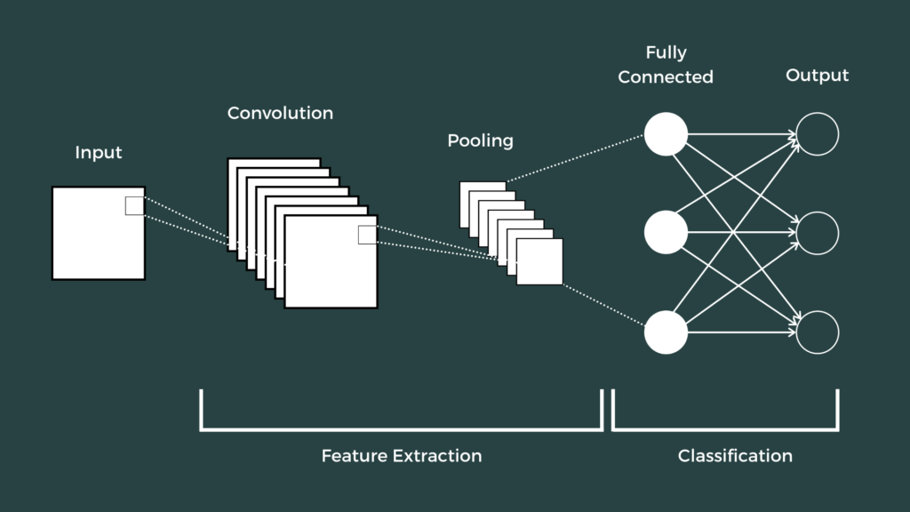

fig: CNN architecture

**Layers of CNN model:**

* **Convolution 2D**
* **MAX pooling 2D**
* **Dropout**
* **Flatten**
* **Dense**
* **Activation**

1. **Convolution 2D :**  In convolution 2D extract the features from the entered image. It gives the output in matrix form.
2. **MAX pooling 2D:**  In MAX pooling 2D it captures very large details on a modified performance map.
3. **Cessation:** Cessation is randomly determined by neurons that are skipped during training.
4. **Flatten:** Complete the feed output into a fully integrated layer. Provides statistics in the listing form.
5. **Density:** A linear function where each installation is attached to each exit in a weighted manner. It is compatible with an indirect activation feature.
6. **Getting started:**  Use the sigmoid feature and expect a zero chance and 1. In the meger version we used binary entropy because we have zeros and layers1. We used the Adam optimizer for the compilation version.

**2.2.** **Proposed System:**

[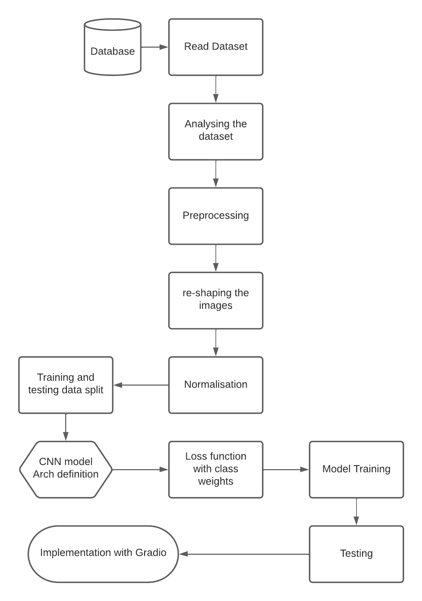](https://lucid.app/documents/edit/1b569ebd-b9df-46cc-ac44-ba6de5589bb9/0?callback=close&name=docs&callback_type=back&v=1071&s=612)

**2.2.1: Technical flow**

* Read Dataset
* Analyzing
* Preprocessing
* 1.Change to same shape
* 2.Normalisation
* Train Test Split
* CNN model architecture definition
* Loss function with class weights
* Model training
* Testing
* Implementation with Gradio

**2.2.2: Dataset**

As we wanted to formulate a real-time Plant Disease Detection System, to infer between the efficacy of pre-trained models over Multi-Class Dataset we collated Plant Leaf Dataset from Kaggle which is open to use. The Dataset consists of 15 Classes with a diverse variety of Plant Leaves elucidated in Figure. There are 20935 instances of Data for scrutinizing the model’s performance. The illustration of the Dataset is shown in Figure.

[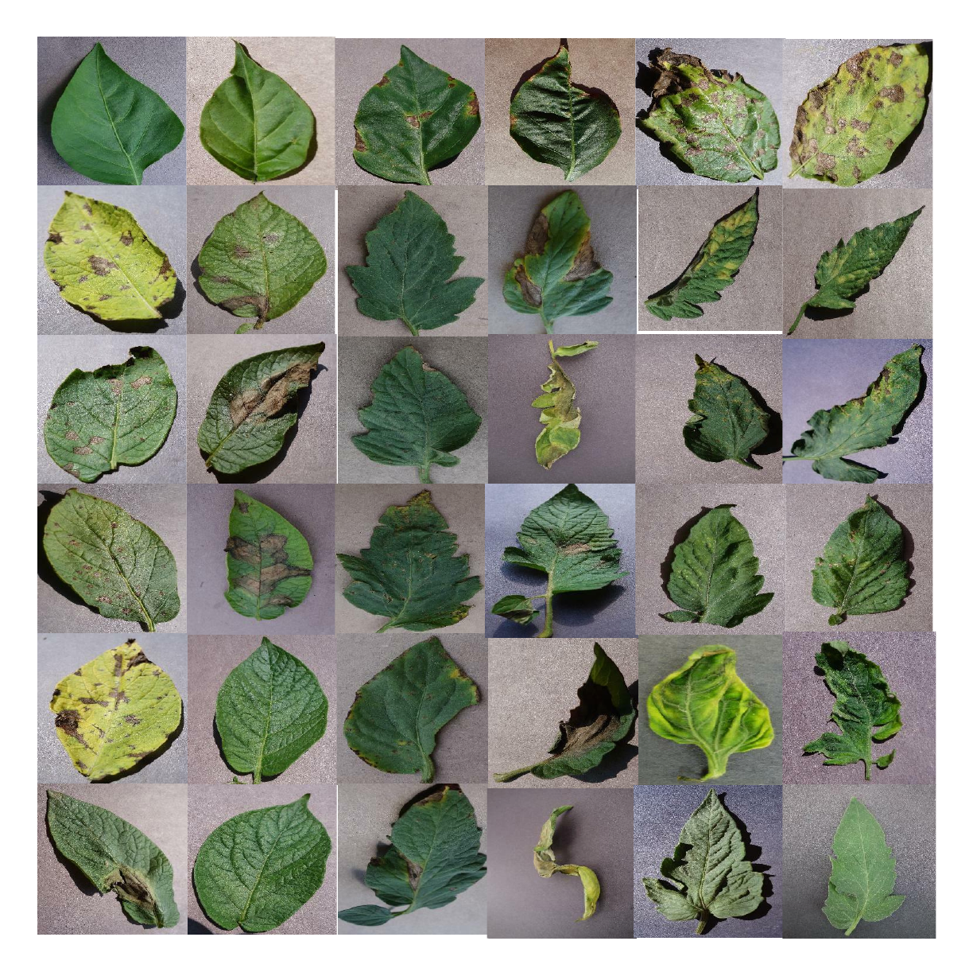](https://lucid.app/documents/edit/979d1151-b94c-473b-a703-b2ccea22a11d/0?callback=close&name=docs&callback_type=back&v=351&s=612)

**2.3: Feasibility Study**

Feasibility study is the first survey of users' knowledge that may estimate service needs, costs, benefits, and feasibility. The feasibility study examines the implementation and operation of the system due to a number of issues. Resources needed for use, such as computer equipment, personnel, and costs, are estimated in this section. Estimated costs are compared to available resources, and system cost analysis is performed. The main objective of a feasibility study is to determine the feasibility of the project, the feasibility of the project, the feasibility of the project. and the feasibility of the planning. Its purpose is to ensure that all project input data is available. As a result, we checked

* Technical feasibility
* Financial feasibility
* Social feasibility

**2.3.1: Technical feasibility**

Diagnosis and Classification of Plant Disease using Deep Learning is a complete project based on In-Depth Reading with minimal Machine Learning. Technologies and associated tools:

CNN

Tensorflow

Google Collaboratory

Seaborn

**2.3.2 Resource Feasibility:**

* Programming device (Laptop)
* Programming tools (freely available)
* Tensorflow
* Google Collaboratory
* Dataset
* Programming individuals

**2.3.3 Financial Feasibility:**

It will cost a very low amount for a project based on Deep Reading(simultaneous). Bug fixes and repair works will have lower costs associated with them. Customers will reap many benefits in addition to the costs associated with it.

**2.3.4: Social Feasibility:**

A component of the audit is to review the level of structure affirmation by the customer. This consolidates the course of setting up the customer to use the structure properly. The level of customer affirmation depends just upon the systems used to show the customer the structure and get that individual familiar with it.

**2.4: Risk Management:**

**2.4.1: Risk Identification**

**2.4.1.1:** Product Size Related

**R1** Memory may be squandered as a result of additional lines of code or redundant algorithms.

**2.4.1.2:** Customer Related

**R2** Since its consumer isn’t a professional individual and it poses a challenge in interpreting the customer's additional specifications.

**R3** If the consumer offers unnecessary details; it can result in an undisclosed danger.

**2.4.1.3:** Process Risk

**R4** A fuzzy or disruptive image may be analyzed throughout segmentation.

**2.4.1.4:** Technical Risk

**R5** The difficulty of CNN would increase if image features are not extracted.

**2.4.1.5:** Development Environment Related

**R6** When a client requests a change or makes an unnecessary alteration later in the implementation process,it is impossible to change the whole system configuration to accommodate the request.

**R7** Inexperience and a lack of tool training can make it challenging to complete project modules.

**2.4.2: Strategies used to manage Risks**

**S1** By reducing redundant coding, we can prevent Chance R1.

**S2** Meeting with the customer regularly reduces the risk to some extent.

**S3** R3 properly develops the system to incorporate modifications at a later stage and retains all necessary paperwork to minimize the risk, as previously stated.

**S4** Use an appropriate noise reduction algorithm prior to segmentation processing.

**S5** Extract the character's feature to reduce the ANN's complexity.

**S6** We have chosen to complete a phased operation model and to transfer the number of employees to our client in the same manner. The ANN component of the project is demanding and extended.

**S7** As consumer demand changes, we will continue to increase the software's functionality.

**S8** We will prevent R7 by providing adequate tool instruction.

**Chapter3: System Analysis and Design**

**3.1. Software Requirement Specification:**

| Βrowser Used🡪 | Google Chrome |
| --- | --- |
| Language Used🡪 | Python |
| Τechnology & libraries Used🡪 | Tensorflow  Numpy  CNN  Keras  Matplotlib  Seaborn |
| Gradio, an open-source python library for creating web-apps | |

## 

* **Tensorflow** :- Tensorflow is an open source planning data data flow for all areas of operations. A number-related library is used for AI applications such as neural networks.
* **Google colab:-** Google collaboration (open-supply Jupyter Notebook interface with excessive GPU space). Google collaboration is an unencrypted Jupyter package that does not need to be set up and works perfectly in the cloud. With colab, you can really write and use code , save and analyze percentages. Access functional computing software, all at no cost in the browser. Jupyter Notebook is an effective way to duplicate and write in your Python code to analyze facts. Instead of rewriting and rewriting the entire code again and again. You can actually write code types and apply them at a time.
* **Seaborn:-** Seaborn is a python library for comprehension by viewing matplotlib. It provides an undeniable level of interaction in drawing attractive and useful measurable drawings. For a brief introduction to the ideas behind the library, you can look up the first notes or paper.
* **OS:-** The OS module in python enables enabling and completing enrollment(envelope), importing, modifying, and separating the current catalog, and more.
* **Matplotlib:-** Matplotlib is a python programming language library and extension of NumPy . Provides article-based API for installing episodes in applications using the most useful GUI toolboxes such as Tkinter,wxPython, Qt or GTK.
* **Pandas:-** Pandas explain() is used to view certain basic mathematical details such as percentage, total, std etc. of a data framework or a series of numerical values. When this method is used in a series of character units, it returns a different output.
* **NumPy:-** NumPy is a Python library used for running with collections. It additionally has the cappotenial to paintings withinside the area of direct polynomial calculations, 4 variables and frames. NumPy evolved in 2005 with the aid of Travis Oliphant. It is an open supply enterprise and you could use it sparingly. NumPy stands for Numerical Python.
* **Kaggle** was used to find an online dataset.
* **GitHub** and **stackoverflow** were used for reference in case of syntax editing errors.
* **Gradio:**- It is used for developing the Web App.
* **OpenCV:**- It is used to read and process images.
* **Sklearn:-** It is used for One hot encoding , train test split and calculating the performance of the model.
* **Language:-**
* **HTML**
* **JavaScript**
* **Python 3 -**  we have used python ,which is R-mathematical programming language instead of MATLAB for following reasons:

– Python records format improved in MATLAB

– Python code is much more understandable than MATLAB

– Keras (with backend of tensorflow) - keras is a neural community API that includes Tensorflow,CNTk, Theno etc. Python programs such as NumPy, Matplotlib, Pandas math and editing graphs.

**3.2. Flowchart:**

[](https://lucid.app/documents/edit/1b569ebd-b9df-46cc-ac44-ba6de5589bb9/0?callback=close&name=docs&callback_type=back&v=1071&s=612)

**3.3. Design and Test Steps:**

The survey of literature gave us an impactful insight about the importance of considering the complexity of the utilized architectures. Thus, we moved on to the explication of our proposed outlook of Plant Disease Detection encapsulating varied modus operandi. The scrutiny of varied pre-trained models was done based on diverse parameters to inhibit computational complexity. There are certain factors which impacts the tuning of certain algorithms which can be elucidated as :

* High Number of Parameters in a model makes it Sluggish to be operated in real-time.
* High Number of Recurring Units, i.e., training over the same structure again and again. After a certain instance, the models perform extremely poor and causes overfitting.
* Utilization of Activation Functions which are complicated deteriorates the performance of the model.
* Deeper the Network more liable it is for causing Overfitting and thereby hindering the modus operandi.

As a result, it becomes prominent to consider the most feasible model for the applicability with greater authenticity. Thus, we collated the most famous Light-weight and Heavy-weight pre-trained models to scrutinize the minutes of the impact of depth of the models, number of parameters, and size of the model over a certain problem statement. We included MobileNetV2 and DenseNet121 as Light-weight Systems and InceptionResNetV2 and VGG16 as Heavy-weight Systems. The basis of selection of these models is elucidated in Table-I.

| **S.No.** | **Pre-Trained Architectures** | **Model Size**  **(In MB)** | **No. of Parameters**  **(approx.**  **in Millions)** | **No. of Layers** |
| --- | --- | --- | --- | --- |
| 1. | MobileNetV2 | 14 | 3.5 | 88 |
| 2. | DenseNet121 | 33 | 8 | 121 |
| 3. | InceptionResNetV2 | 215 | 55.8 | 572 |
| 4. | VGG 16 | 528 | 138 | 23 |

Now, as the model selection was carried out through explication over varied references, we tried to understand the architecture of each model. As a result, Figure.1, Figure.2, Figure.3, and Figure.4 demonstrate the graphical illustration of specifics of the model and the minutes of layers in those models.

*A. MobileNetV2:*

As per the Table-I, MobileNetV2 consists of 88 Layers with 3.5 Million Parameters overall and the size of the model is just 14MB. Thus, it has been considered as the Light-Weight Model when compared to other pre-trained models.

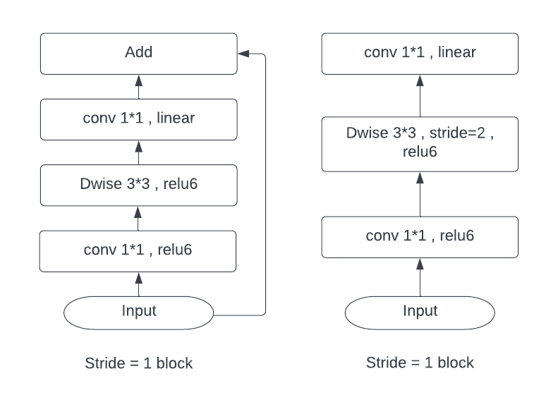

Fig .1. Demonstration of MobileNetV2 Architecture with Residual and Downsizing Block [16].

*B. DenseNet121:*

As per the Table-I, DenseNet121 consists of 121 Layers overall, along with 08 Million Parameters colligating a size of 33MB, making it also a Light-Weight System when compared to other pre-trained models.

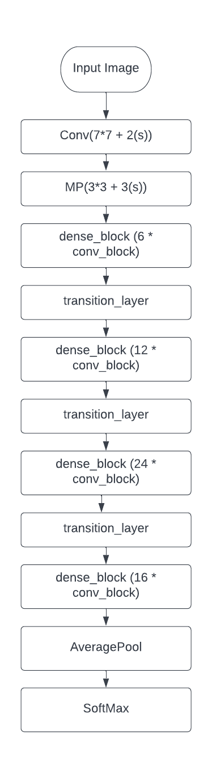

Fig .2. Demonstration of DenseNet121 Architecture [16].

*C. InceptionResNetV2:*

As per the Table-I, InceptionResNetV2 is the collation of Inception and ResNet Family of Pre-Trained architectures consisting of 572 Layers with 55.8 Parameters. The Size of the Model is 215MB making it a Heavy-Weight System when compared with other pre-trained models.

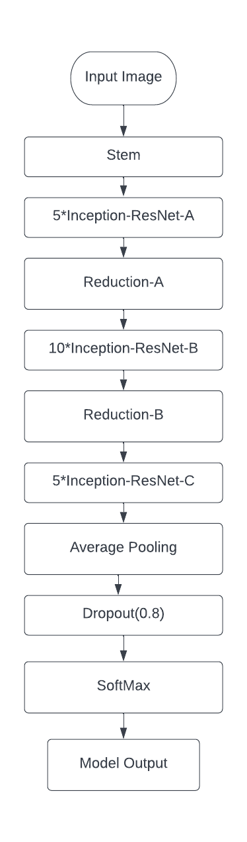

Fig .3. Demonstration of InceptionResNetV2 Architecture [16].

*D. VGG16:* As per the Table-I, VGG16 consists of 23 Layers with 138 Million Parameters. The size of the model stands to be 528MB, making it a Heavy-Weight System when compared to other pre-trained models.

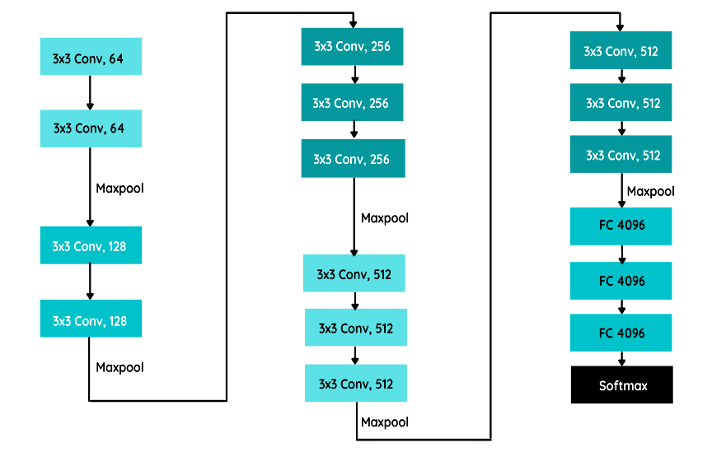

Fig .4. Demonstration of VGG16 Architecture [16].

These architectures stand out to be prominent for our modus operandi and aids us to understand the behavior of models for Multi-Class Dataset and thereby creating a real-time system for Plant Disease Detection.

**3.4. Testing Process:**

Testing is the technique engaged with endeavoring to perceive each possible flaw or weakness in the thing product. It is an item application to ensure that the item structure experiences its necessities and wants of customers and doesn't crash and burn in an unacceptable way. There are different sorts of tests. Every sort of test meets a specific test need.

**3.4.1: TYPES OF TESTS**

* **Unit testing**

Unit testing incorporates the arrangement of test conditions that ensure that the inside system understanding works properly, and that structure inputs produce significant outcome. All pieces of decision and stream of inside code ought to be affirmed. Testing of each item unit of the application . This is a preliminary of the plan, considering data on its turn of events and attack. Unit testing performs fundamental tests at deficient level and tests a specific business cooperation, application, as well as structure plan. Unit testing ensures that each intriguing business process procedure works unequivocally in the formed detail and contains clearly portrayed information sources and expected outcomes.

* **Integration testing**

Tests run the event and are extraordinarily stressed over the major effect of screens or fields. Blending tests show that though the parts were only satisfied, as affirmed by the accomplishment of the unit test, the part parts are consistent and stable. Blending tests are unequivocally planned to perceive issues arising out of compound parts.

* **Functional testing**

Valuable testing offers organized hints that attempted endeavors are available as directed by business and advancement necessities, structure documentation, and customer manuals.

Functional assessment focuses on the following:

* Valid Input: Specified categories of valid entries should be accepted.
* Invalid Input: The specified categories for invalid input should be rejected.
* Tasks: The specified tasks should be used.
* Output: Specified categories of application results should be used.
* Systems: Processing systems or processes should be used.

The arrangement and change of execution assessments bases on exceptional requirements, endeavors, or phenomenal analyses. Additionally, conscious wellsprings of data related to perceiving the movement of Business process; data fields, pre-portrayed cycles, and progressive cycles should be considered for testing. Before the display test is done, additional tests are not actually settled forever the effective worth of the current test.

* **System test**

It truly investigates the plan to certify known and obvious results. An outline of a system test is a structure blend test zeroed in on fix. Structure testing relies upon process depictions and transfer, which highlights associations with pre-run cycles and compromise centers.

* **White Box testing**

The White Box is a test where the item analyzer is familiar with within working, development and language of the item, or on the other hand if nothing else its inspiration. It is purposeful. Used to examine closed off areas from the disclosure level.

* **Black Box testing**

Discovery Checking programming with close to no data on the inside limit, plan or language of the test module. The disclosure test, similarly as other various types of tests, should be written in an asserted source, still up in the air chronicles or requirements, for instance, a specific or necessities record. Testing gives data and responds to results dismissing how the item capacities.

37

**1.Unit testing**

Unit testing is generally done as a component of the code coordinated with the product life cycle unit test segment, in spite of the fact that it is normal for coding and unit testing to be done as two separate stages.

**Test objectives**

• All field passages should work appropriately.

• Pages ought to be empowered from the predetermined connection.

• Login screen, messages and answers ought not be deferred.

**Features to be tested**

• Make specific the entrance is in the best configuration

• No copy sections ought to be permitted

**2 .Integration Assessmen**t

Programming compromise testing is the slow testing of the coordination of somewhere around two consolidated programming parts into one region to convey dissatisfactions coming about due to interoperability hurt.

Reconciliation test capacity to check whether programming parts or applications, for example portions of the product framework or - one move forward - the product applications at the organization level - connect without mistake.

**3 .Admission Test**

Client Recognition Testing is a significant period of any task and requires huge end client support. It additionally guarantees that the framework meets working prerequisites.

Test results: All of the experiments referenced above have been effective. There are no mistakes experienced.

**Implementation**

*A. Dataset Utilized:* As we wanted to formulate a real-time Plant Disease Detection System, to infer between the efficacy of pre-trained models over Multi-Class Dataset we collated Plant Leaf Dataset from Kaggle which is open to use. The Dataset consists of 15 Classes with a diverse variety of Plant Leaves elucidated in Figure.5. There are 20935 instances of Data for scrutinizing the model’s performance. The illustration of Dataset is shown in Figure.5.

[](https://lucid.app/documents/edit/979d1151-b94c-473b-a703-b2ccea22a11d/0?callback=close&name=docs&callback_type=back&v=351&s=612)

Fig .5. Demonstration of Plant Leaves Dataset.

*B. Frameworks Utilized:* TensorFlow and Keras have been induced for working upon Deep Learning Architectures. OpenCv is used for reading and processing images. Numpy for saving the images in array format. Sklearn for one hot encoding,training and testing split, calculating the performance of the model. Matplotlib and Seaborn for plotting graphs in a much more advanced way. Gradio, an open-source python library for creating web-apps has also been utilized for creating a web app for Plant Disease Detection.

*C. Accuracy Parameters:* As the Data has been split into Train, and Test set. The Training Accuracy, and Test Accuracy has been used for explaining the architecture's potency over the particular dataset. Also, the Confusion Matrix is used for scrutinizing the model’s efficacy in real-time over different labels/classes.

*D. Workflow:* The dataset that we have taken was having 15 categories of plants. The dataset was very unbalanced, due to which we got many false positive predictions. So in order to handle the unbalanced dataset there are three ways,

1. Make an equal number of samples in all the categories by reducing the samples.
2. Generate more samples in those categories of plants which were having less number of samples.
3. Make use of class weights.

So we used the class weight method to balance the dataset. Working steps of class weight method - the class weight doesn’t reduce or generate samples to make the dataset balanced, instead it makes the dataset balanced while training by providing an array, defining how much weight to be given to each category or class, such that the model trains or learns that the dataset is in equal distribution.

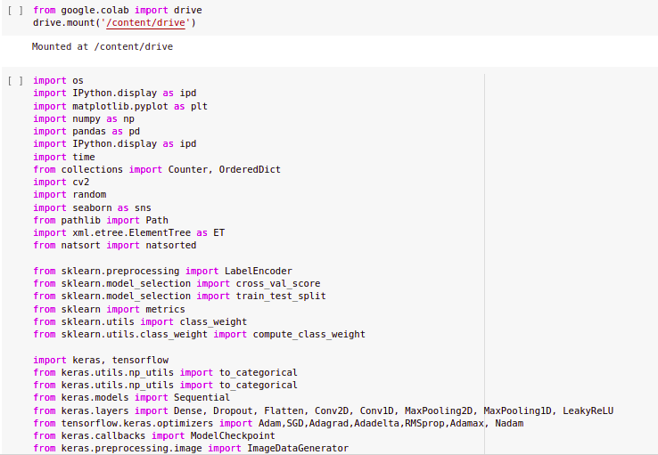

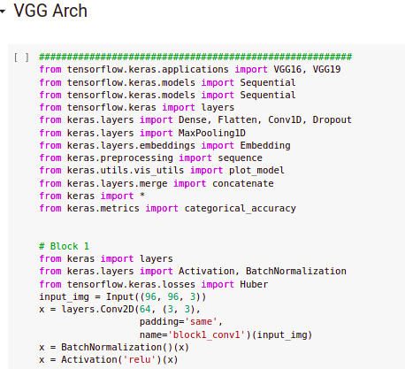

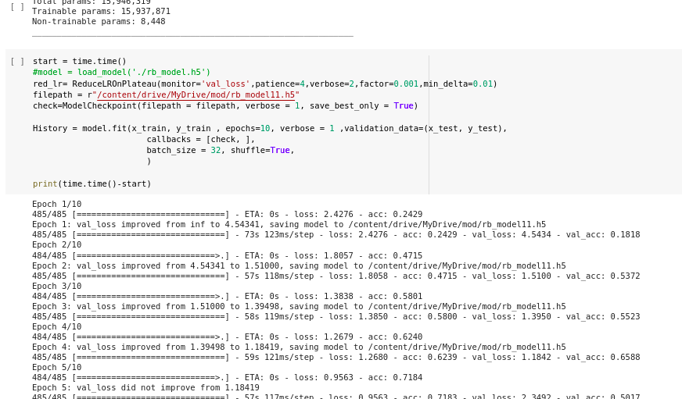

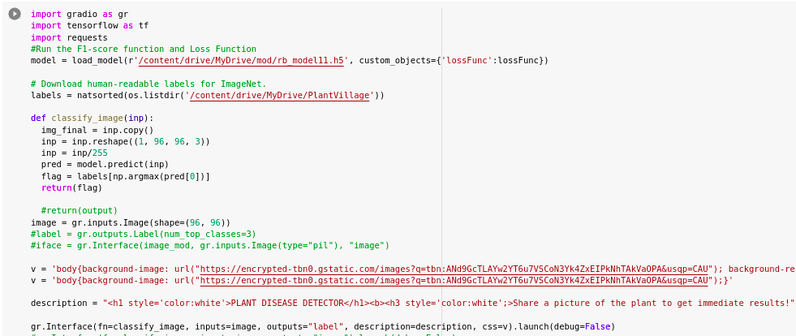

**Chapter4: Result**

After the Implementation of the proposed outlook, we got phenomenal results for the model that we have selected for building the Plant Disease Detection System which was VGG16 and a worthy insight was procured through it. Below figures represent the graphical perspective of the model in terms of Accuracy and Loss.

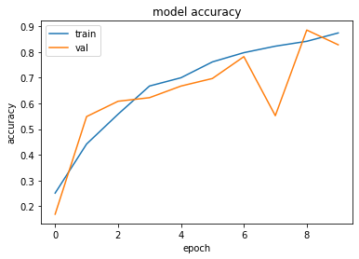

Accuracy Results for VGG16.

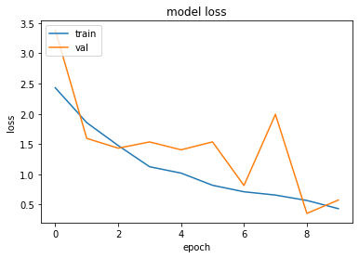

Loss Results for VGG16.

As we have used VGG architecture for training the model and from that we achieved 97% of accuracy, and made the calculation of precision, recall, F1-score for each class. Below figures demonstrate the precision ,recall and F1-score for each class.

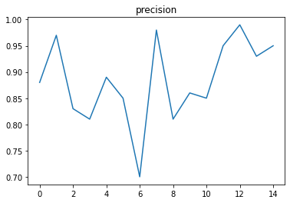

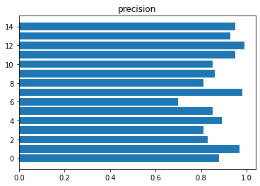

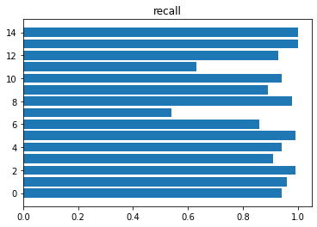

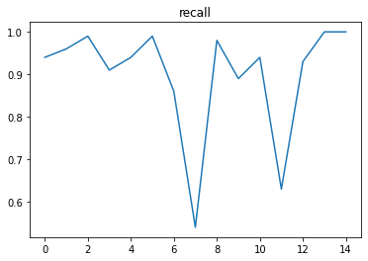

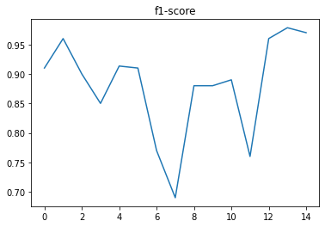

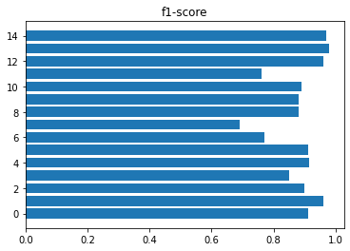

Table-II, illustrates the Accuracies obtained for Training, Validation and Test Data for the VGG16 model.

TABLE II. Analysis of pre-trained architectures based on their accuracies over Plant Leaf dataset.

| Model | Training Accuracy  (%) | Test Accuracy (%) |
| --- | --- | --- |
| VGG16 | 97.51 | 97.33 |

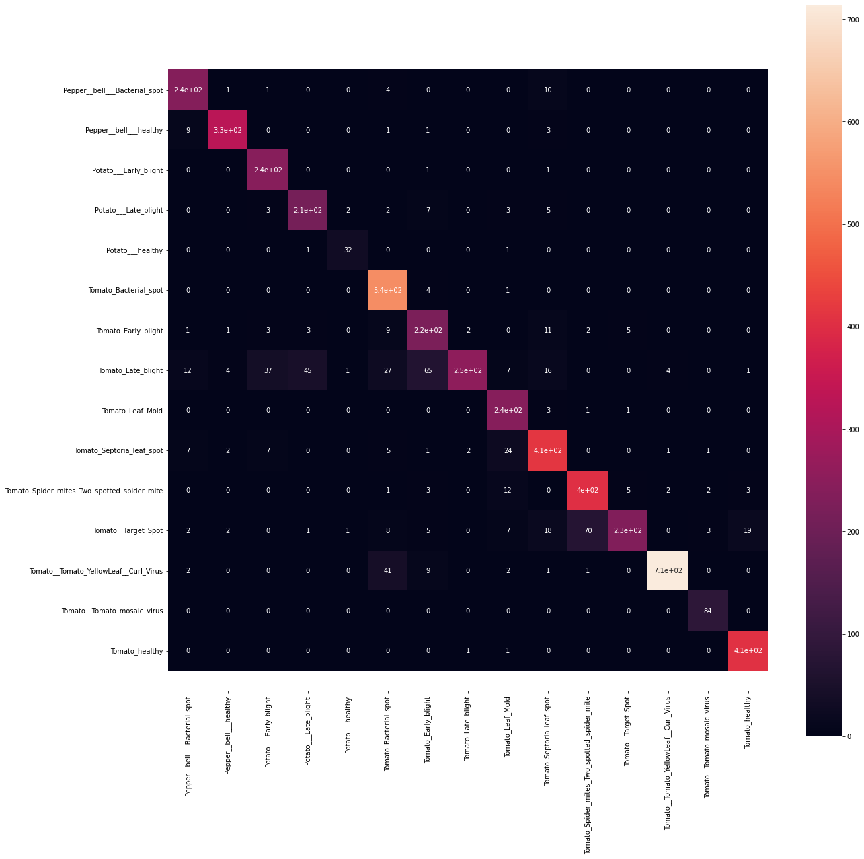

Confusion Matrix

**WEB APP:**

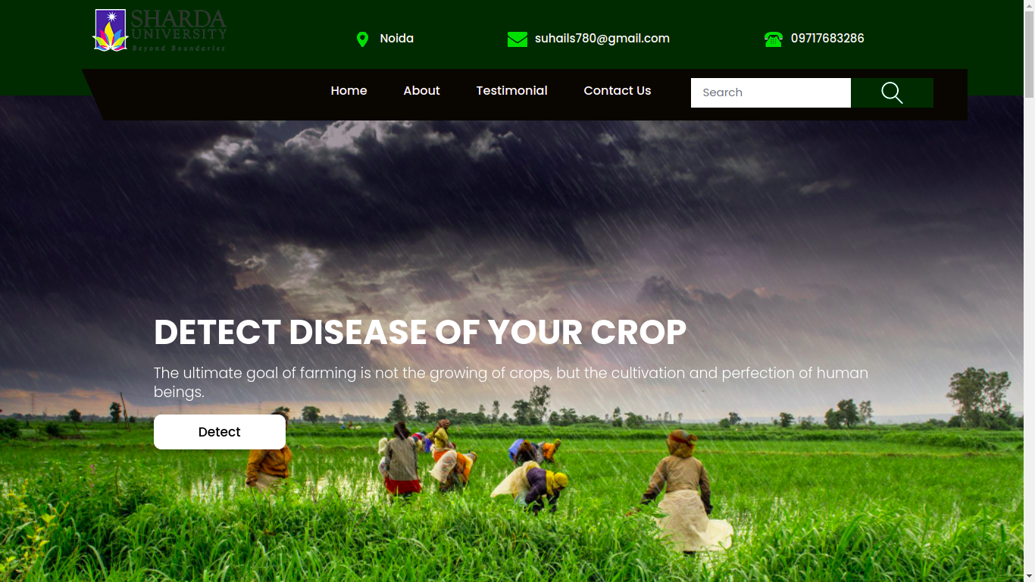

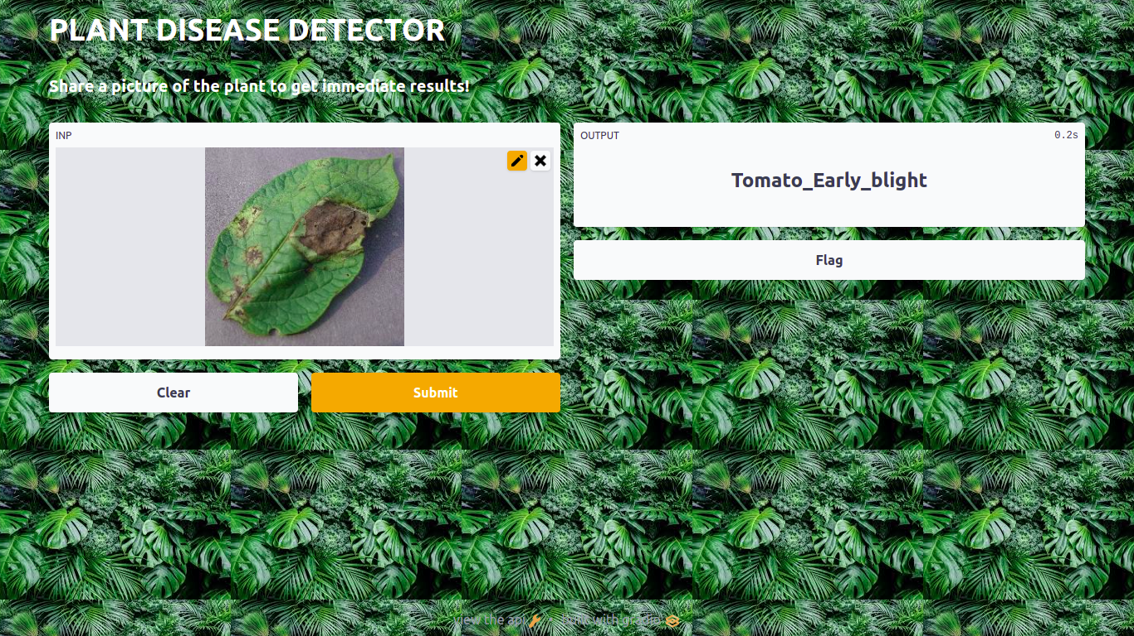

**Chapter5: Conclusion**

Plant disease detection has become a very big domain to work on, because many of the works have been done earlier using many different technologies and methods in this field. We so far have read some of the papers for our survey and have analyzed and have found many different results for different techniques and methods used. The papers were on the same topic but of different methodologies like few of them were based on MobileNetV2, DenseNet121 InceptionResNetV2 and VGG16 etc. We have analyzed that even after doing so much research in this domain, there is a large scope of research in the future also because every proposed model has some constraints, some disadvantages and some advantages. The need for a perfect model to detect the plant leaf disease is also in hunt and this is the reason that these models are not getting used on a large scale for disease detection. This is a very good and very helpful domain to work on because when farming is done on a very big scale, it is not possible for farmers to look for diseases on every leaf of the plants, so further research and findings on this domain can be very helpful.

So after comparing the results of different models, VGG16 architecture is the best modus operandi as it works better with small data and large data also and after our research we got the accuracy of 99% in some of the present classes, like the category Tomato_Target_spot is the least accuracy scored which is 82% the category Pepper_bell_healthy, Potota_b, etc are the highest accuracy scored which is more than 99%

As a result, it’s necessary to scrutinize over varied architectures for finalizing the base model for any modus operandi. The efficacy we got stands out as the best in assuaging this system and more dataset can be amalgamated for greater explication as an outlook.

**Chapter6: References**

1. J. G. A. Barbedo, ‘‘Plant disease identification from individual lesions and spots using deep learning,’’ Biosyst. Eng., Vol. 180, PP 96–107, Apr, 2019
2. Liu, Y. Zhang, D.-J. He, and Y.-X. Li, ‘‘Identification of apple leaf diseases based on deep convolutional neural networks,’’ Symmetry, Vol. 10, No. 1, pp 11–19. Dec, 2018.
3. H. Larochelle, ‘‘Few-shot learning,’’ in Computer Vision: A Reference Guide, 2nd ed., K. Ikeuchi, Ed. Tokyo, and Tokyo: Univ. Tokyo Press, 2014.
4. Shima Naresh, Ramchandra Habbar et al. “Plant Disease Detection Using Machine Learning”, IEEE, 13 Aug 2018.
5. Parul Sharma, YPL Singh et al “KrishiMitr (Farmer’s Friend): Using Machine Learning to Identify Diseases in Plants”, IEEE, 7 Jan 2019.
6. Shital Bankar, Ajita Dubey et al. “Plant Disease Detection Techniques Using Canny Edge Detection & Color Histogram in Image Processing”, International Journal of Computer Science and Information Technologies, Vol. 5 (2) , 2014, 1165-1168.
7. ZN Reza et al. “Detecting jute plant disease using image processing and machine learning”, IEEE, 9 March 2017.
8. MS Arya, K Anjali et al. “Detection of unhealthy plant leaves using image processing and genetic algorithm with Arduino”, IEEE, 14 June 2018.
9. R T Narmadha et al. “Detection and measurement of paddy leaf disease symptoms using image processing”, IEEE. 23 Nov 2017.
10. M Poobalasubramnium et al. “Plant Disease Identification and Detection Using Support Vector Machines and Artificial Neural Networks”, Artificial Intelligence and Evolutionary Computations in Engineering Systems (pp.15-27). Jan 2020.
11. Tejas Tawde, Kunal Deshmukh et al. “Rice Plant Disease Detection and Classification Techniques, A Survey”, IJERT, volume 10, July 2021.
12. Vittal S Gutte et al. “A Survey on Recognition of Plant Disease with Help of Algorithm” IJESC, Volume 6 Issue No. 6, Juy 2016.
13. Murk Chohan, Adil Khan et al. “Plant Disease Detection using Deep Learning”, IJRTE. ISSN: 2277-3878, Volume-9 Issue-1, May 2020.
14. RU Khan, A Khan et al. “Image-Based Detection of Plant Diseases: From Classical Machine Learning to Deep Learning Journey”, Hindwani, Volume 2021 |Article ID 5541859. June 2021.
15. Yang Juo, Zing Jhang et al. “Plant Disease Identification Based on Deep Learning Algorithm in Smart Farming”, Hindwani, Volume 2020 |Article ID 2479172. Aug 2020.
16. S. A. Dwivedi and A. Attry, "Juxtaposing Deep Learning Models Efficacy for Ocular Disorder Detection of Diabetic Retinopathy for Ophthalmoscopy," 2021 6th International Conference on Signal Processing, Computing and Control (ISPCC), 2021, pp. 352-357, doi: 10.1109/ISPCC53510.2021.9609368.

**GITHUB LINK**

<https://github.com/Suhailsaifi780/Plant-Disease-Detection-Using-Deep-Learning-Web-App.git>